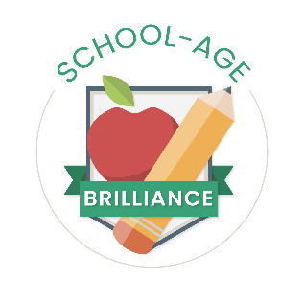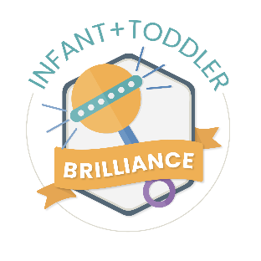
The Division of Child Care has designed a pathway for early educators to focus on a specific topic of professional learning and recognition of the knowledge and skills in the form of a digital badge.
What is Digital Badging?
A digital badge is an indicator of accomplishment or skill that can be displayed professionally to show achievement. Digital badges are portable, sharable, and stackable snapshots of targeted professional learning in the areas of Infant and Toddler and/or School Age content.
How it will work
- The Kentucky Division of Child Care badges will be 30 total hours of completed professional learning that is approved Infant and Toddler or School-Age content.
  - Approved coursework will be identified by the ECE-TRIS training type that corresponds with the course/training.
  - Coursework is valid for the digital badge dating back to November 8th, 2021.
- The 30 hours will include at least 4 hours of learning in each core content area. 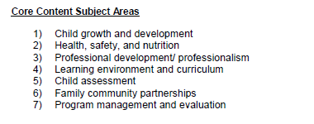
- Badge progress will be automatically tracked on the users ECE-TRIS account. After logging in and scrolling below the box that is labeled “My Information”, there will be a link to “View Badge Progress” (See highlighted below).
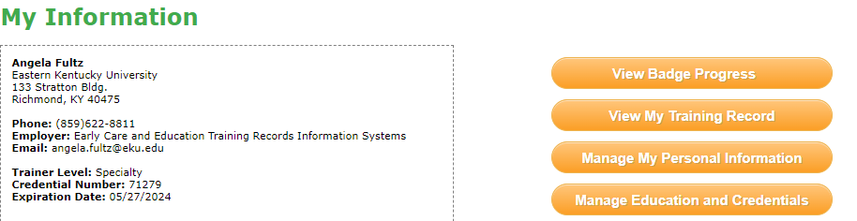

- Upon clicking “View Badge Progress”, a window will appear that has the badge types listed:
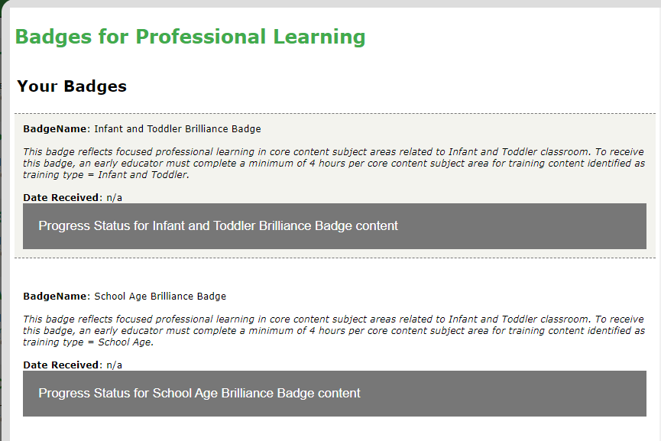

Each of the badge types are clickable and expand to display a progress bar for completed coursework in each of the seven (7) Core Content Subject Areas.
Here is an example of progress in several subject areas for the Infant and Toddler Brilliance Badge:
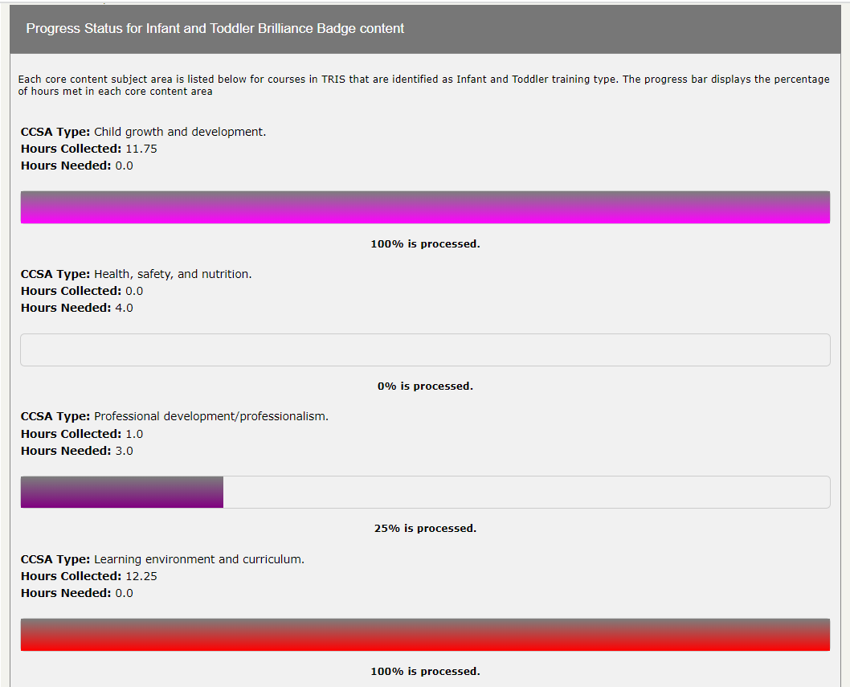

How to Start your Badge Journey
- Using the ECE-TRIS Calendar/Approved Training Area, choose the training type for the badge you would like to earn. All trainings that have been approved for the badge will display in the results.
- Review your badge progress bar often to check the hours in each core content area. Remember you will need at least 4 hours in each area.
- The ECE-TRIS Calendar/Approved Training area will also assist you when you need to narrow your results to specific core content areas. Here is an example for the Infant Toddler badge.
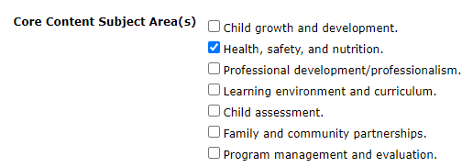

- The ECE-TRIS team will monitor progress to award the badge after the 30 hours.
- Automatic notification will be sent from Eastern Kentucky University noreply@badgr.com
Example of email below.
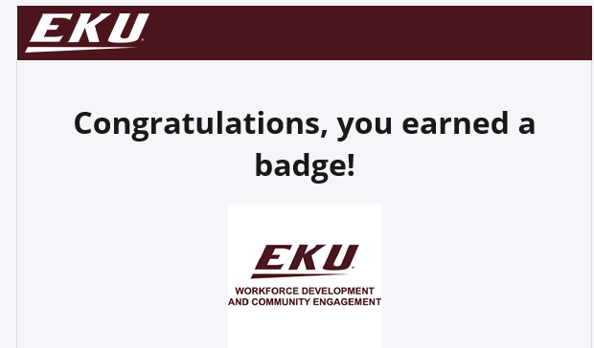
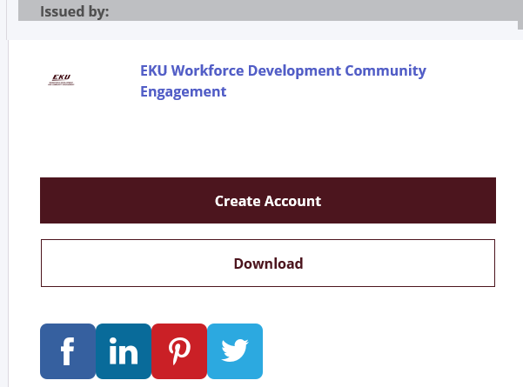

- Once downloaded, you can attach the digital badge to your Linkedin Profile, Email signature, Facebook, or Resume.

Badge Awards
In partnership with the Governor’s Office of Early Childhood and funding made possible by the Preschool Development Grant, we are offering a bonus incentive for the Brilliance Badges at fifty dollars ($50.00) each. The Division of Child Care will be reporting providers that earn badges to the Governor’s Office of Early Childhood, who will be distributing funds for earned badges. Providers are eligible for only one incentive in each badge type. You will receive a letter alongside your badge that details your next steps to receive the $50.00 incentive. This letter will contain a link to complete the required documents. Providers are responsible for completing all informational or tax forms necessary for payment.
Badge incentives can be applied for and received only as funding is available through the Preschool Development Grant administered by GOEC.
Public Preschool Providers:
- If you are not already in ECE-TRIS, you will need to set up an account.
- Once you set up your account, you can begin tracking professional development hours to earn badges. Be sure to submit trainings/professional development for approval 30 days prior to the training session.

Beyond the Badge: A look at the new Infant Toddler and School-Age Credentials
The Division of Child Care is also offering a next level credential that builds upon the 30 hours already received with the digital badge. Learners who want to continue focusing their professional learning in the Infant Toddler or School-Age pathway can seek a corresponding credential. These credentials are currently undergoing legislative review (as of 11/8/2023).
Process for the Credential
- Much like the badge, additional targeted training will be needed in the 7 core content subject areas. For example, the Level One (1) credential would require 30 more hours across each content area.
- These hours are not calculated automatically with the same progress bar as the first 30 hours, but you will use the same steps to find allowable trainings on the ECE-TRIS Calendar/Approved Training area.
- Learners will apply for the online credential through ECE-TRIS once they have met the training hours. There will be additional requirements as part of the application process, like specific trainings or certifications.
- Be on the lookout for more information as it is shared from DCC!

